Abstract:

Errands business services is an Internet grocery service business organization whose mission is to help shoppers to plan ahead their food shopping from order to delivery so that it fits flexibly into their daily schedule. its idea is conceptualized to solve problems of shopping and delivery of quality and affordable products in good shape to the residents of Lagos state, Nigeria.

BY:

FEASIBILY STUDY FOR ERRANDS BUSINESS SERVICES

INTRODUCTION

The usefulness of the Internet cannot be overemphasized, its inception has had tremendous effects on how individuals and organizations communicate and interact all around the world. Shopping is gradually revolutionized from the traditional face-to-face shopping to a digitalized approached prompted by the advancement in technology(internet). The traditional shopping of visiting then store is fast being displaced by online shopping, especially in developed countries, where many customers shop online. Consumers worldwide shop online 24 hours a day, through online Shopping. Some market sectors, including insurance, travel agency music industry and automobiles, are experiencing rapid growth in online sales.

Groceries are the food and other items that you buy in a food store or supermarket, this includes fruits, flours, bread, meat, chicken, fish, eggs, vegetables, canned food, dairy products such as milk, yogurt, cheese. as well as fresh food items like beans, rice, potatoes etc. With the emergence of new technology such as refrigeration, registers, inventory equipment, and the internet, the ability to shop has become easier, faster, and certainly more efficient. The earliest form of grocery shopping was the public market. They were the main food markets for the nation, much longer than any other establishment for food retailing in U.S. history. For about three hundred years, many cities and towns depended on the public market as their main retail food source. Butcher, farmers and other merchants sold their goods on the street without buildings. (Mayo) The website acts as a means of communication that the physical store does not provide. Grocery shopping is faster, more reliable, more individualized, and much more convenient (Bittman and Murphy). Analysts say that the current group of Web grocers will earn significant profits if they can utilize the latest technology and gear consumer attitudes toward the Internet.

Technology keeps advancing every day and spreading fast across the world. This has provided several businesses an opportunity to take advantage of by having an edge to reach a high number of people through the simple medium of the Internet. Businesses can advertise and even sell their goods online. This process of selling goods online is what is referred to as online retailing. It is otherwise referred to as online shopping, e-commerce, e-shopping, Internet shopping and so on(Doherty and Ellis-Chadwick). The online business sector is regarded as the most advanced in the application of new and innovatory Internet technologies when providing market services through the Internet(Hagel, J.).

In Nigeria, in spite of the serious economic problems the country is facing such as low income per capita and irregular power supply, Internet usage is increasing at a very high rate. This new trend of online shopping is now being embraced by businesses with physical stores. Nigeria is the fastest growing telecommunications country in Africa (Ayo, C., et al) the country has witnessed an upsurge in the number of Internet retailers (e-tailers) who attract shoppers into their web sites and encourage them to window shop, search for products, make price comparisons, and ultimately purchase products. Some of the more prominent e-tailers in Nigeria include Jumia.com.ng, Konga. com, Kaymu.com, Dealdey.com, Slot.ng, Taafoo.com and a host of others

Errands business services is an Internet grocery service (IGS) business organization whose mission is to help shoppers to plan ahead their food shopping from order to delivery so that it fits flexibly into their daily schedule.

Lagos State is a state in southwestern Nigeria, it is both the most populous and smallest in area. The State is bordered on the west by the Republic of Benin and on the south by Atlantic coast, as well as north and east by Ogun State of Nigeria, making it the only state in the country to border only one state. Lagos state has a total population of 9,013,534(NPC 2006) in relation to the national count of 140,003,542, however Lagos state is said to have about 24.6 million inhabitants in 2015 and the state population is expected to hit 35 million mark in 2020. Lagos state has a landmass of 356,861 hectares of which 169,613 hectares are designated for agriculture and only 30% has been utilized. Since majority of groceries are from Agriculture, hence the state won’t be able to produce enough groceries for its inhabitants, leading to the shipping of those groceries from other states in the country. Due to perishability of some of this farm produce they are unhygienically preserved by road side traders in most case causing spoilage thereby leading to inhabitants sourcing for their groceries from supermarkets and internet groceries stores. Also among Lagos state challenges is Traffic congestion. An average commuter in Lagos spends over 3 hours in traffic every day, which make Lagos one of the most congested cities in the world, due to rising car ownership, 40% of new cars are registered in Lagos and these also contribute to both noise and air pollution. Efforts have been made to reduce traffic congestion in the state such as the introduction of bus rapid transit (BRT) which is provided a separate lane to travel.

Statistical data on urban farming in Lagos is scanty but we observed that the population of urban farmers is on the increase. Urban farming in wider Lagos include poultry keeping; artisan fishing in coastal villages; roadside horticulturists; market gardens at flood plains and free-range herds on coastal grasslands of littoral local council areas. As stated by Hardy et al. (1996), most cities draw on rural areas within their regional setting for food resources. Metropolitan Lagos is a typical example. Unpublished research works have shown that the bulk of local poultry products, garri, fruits and vegetables are from the South Western states of Nigeria especially Ogun, Oyo and Ondo states. Northern states in the North Eastern and North Western geo-political zones of Nigeria supply beef and mutton. A more glaring example is fish consumption in the metropolis. Studies by Ashiyanbi (2005) revealed the supply deficit of fish from local sources to be 158,266 m tons. This deficit encouraged massive importation of smoked fish from neighboring states and frozen fish from European countries.

EXECUTIVE SUMMARY

Errands business services idea is conceptualized to solve problems of shopping and delivery of quality and affordable products in good shape to the residents of Lagos state, Nigeria. With a probability of scaling the business services to other highly populated cities of the country with similar heavy traffic and limited access to fresh food stuff from farm.

OBJECTIVE AND MARKET

The past decade has Proposed significant developments in mobile commerce (mobile commerce), which opens up severe prospects in the future to increase the size and transmission of trade (Wong et al., 2012; Yang and Kim, 2012). The new development in the mobile phone leads to almost every home through the services and advantages. This led companies to create services called m-services that help customers browse or buy products and services from merchants via mobile devices anywhere and anytime (Wong et al., 2012; Yang & Kim, 2012).

Errands business services target market are the inhabitants of Lagos state, Nigeria. And its main prospective customer is working class female and bachelors who after a hectic day at work spend about 3 hours again in the traffic congestion within the state before arriving in their various place of resident. After going through this stress, they tend to get tired on arrival to their various homes, groceries being an essential commodity they look for other means of acquiring them, this is where Errand business services comes in. The business service will enable shoppers to shop groceries online through the business app and website. Shoppers pay online to the retail shop available on Errands business services platform which will include Super Shoppy, Justrite, Spar, Shoprite and Alpha Mart. After shopping their groceries online, shoppers will be able to match up their item to either of the two delivery companies Errands business services has on its platform and also pay online to the delivery company, after which Errands business service will track the goods and see to it that it arrives in good shape to the destination of the shopper. However, unlike other online grocery store of which some doesn’t have delivery incorporated in their operation, and those with delivery tend to deliver the groceries late to the customers. we will be partnering with five most influential grocery store/supermarket in the state such that customer can order items from more than one store and till get all their goods delivered swiftly and secure.

Errands business services intend to get across prospective customers via different advertisement means such as social medias, billboard, television, also through search engine optimization and marketing (SEO & SEM). While Errand business services will generate its profit from the partnering store on our mobile app / website with an agreement of between 3% – 10% on orders placed on our mobile app, which is based on the cost of goods purchased by customers at a go and 5% from the delivery companies

The goal of errands business service is to realize a market share in the Lagos state through the facilitation of grocery shopping online for inhabitants of Lagos. The objectives of the business are as follows:

* To establish an online grocery store Application/web interface where users can search for products, view a complete description of the products and order the products.
* A search engine that provides an easy and convenient way to search for products specific to their needs. The search engine would list a set of products based on the search term and the user can further filter the list based on various parameters.
* Achieve a new market where it will be able to make profits
* Introduce new shopping strategy and become the largest market shareholder
* Meet the consumer demands and satisfactions by helping them with shopping and delivering the products on time to all customers
* Achieve the organizational goals and objectives as well as making profits.
* Use the internet and social networking sites as well as the mobile phones to market the company’s products
* Create a positive company image and repetition so as to place itself above the par of other competitors.
* Become the leading online grocery store in Lagos state in a period of six months.

SPECIFICATIONS OF THE SERVICES

Errands business services will serve as a link between shopper, groceries store/supermarket and the delivery company through our online platform, which comprises an order management system that streamlines the entire ordering process, starting from order placement to final delivery and see to it that the good to be delivered to the shopper are acquired and delivered in good state. It relies on mobile-based software, application and website that offers shoppers access to numerous groceries stores/supermarkets available on our platform, based on the preference of the customer after which the goods will be handed over to the delivery personnel to deliver to the consumer swiftly and in good condition, thereby saving the buyer from the hassle of travelling and standing in long queues just to purchase their groceries. Furthermore, it allows the shopper track the location of the delivery personnel and check routes taken by them.

PROPOSED APP IMPLEMENTATION AND SETUP

This section presents the implementation of the mobile shopping grocery and new development in information technology and image processing (Al-Hatmi & Yousif, 2017; Yousif, 2011). This application information is an online mobile app that works with different platforms, such as android and IOS. Also, it offers various functions that facilitate the customer needs and introduce multi-functions, such as push notifications and intelligent data aggregation (Abusham & Al.Zaabi, 2021). A secure database that saves user information privately and does not share this information with anyone other. In addition, a secure payment method using PayPal and other trust methods. Convenience of the shopping process as one of the major factors influencing customers’ perceptions towards online shopping. This means the easier it is for customers to engage in online shopping the more likely they are to engage in it (Meehan, K. 2000). Figure 1 presents the USE-Case diagram that shows the actors and the main function in the proposed system, which has two main actors (admin and user). The guest can see only the first screen of the application. A pop-up message will appear after a certain period asks the quest to complete the registration process. The user with an account can uses logins to the system, orders the product and pay its price in the system (app). The administrator (admin actor) has the authorization and permission to manage the system activities, as show in Figure 1.

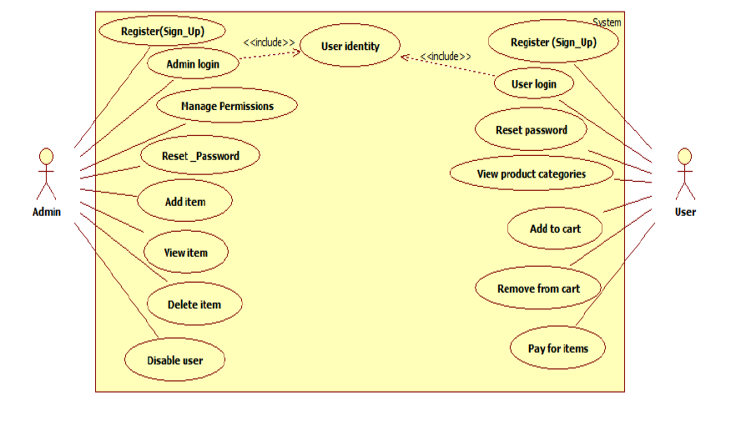

Figure 1. the USE-Case diagram of the proposed app

Figures 2 to 5 show the home page of our website, items categories and subcategories that include item specifications, such as name, description, rate, price, and add to cart.

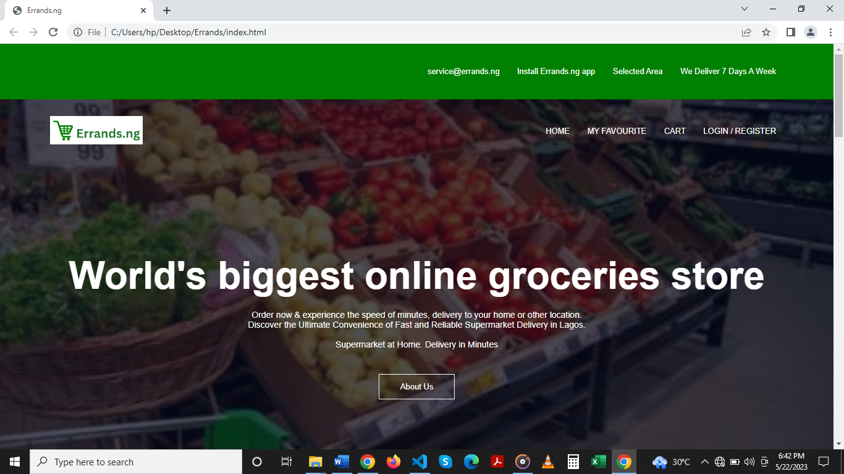

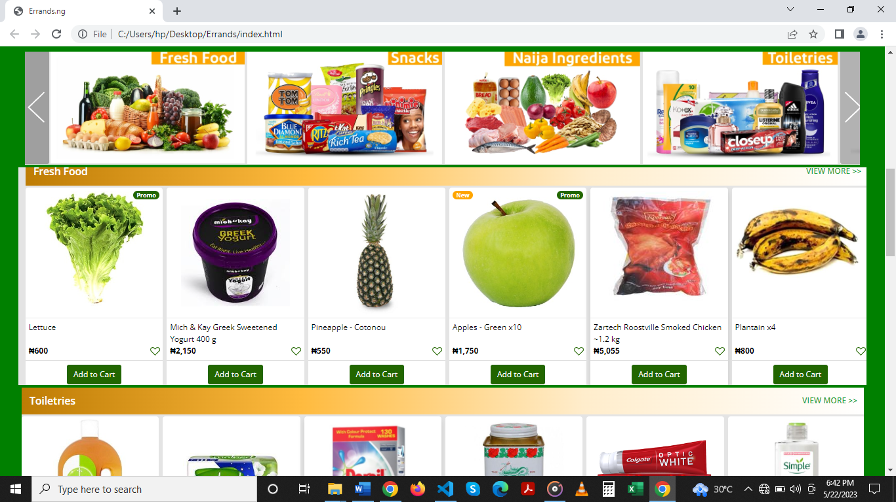

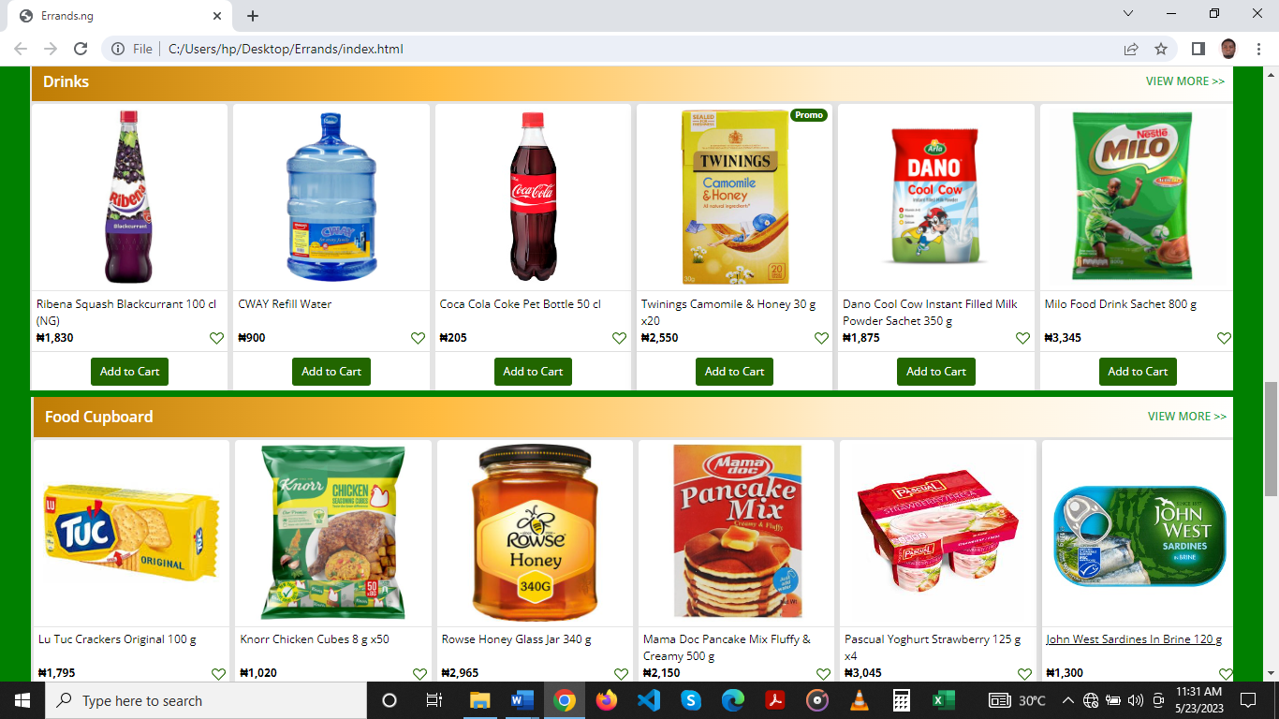

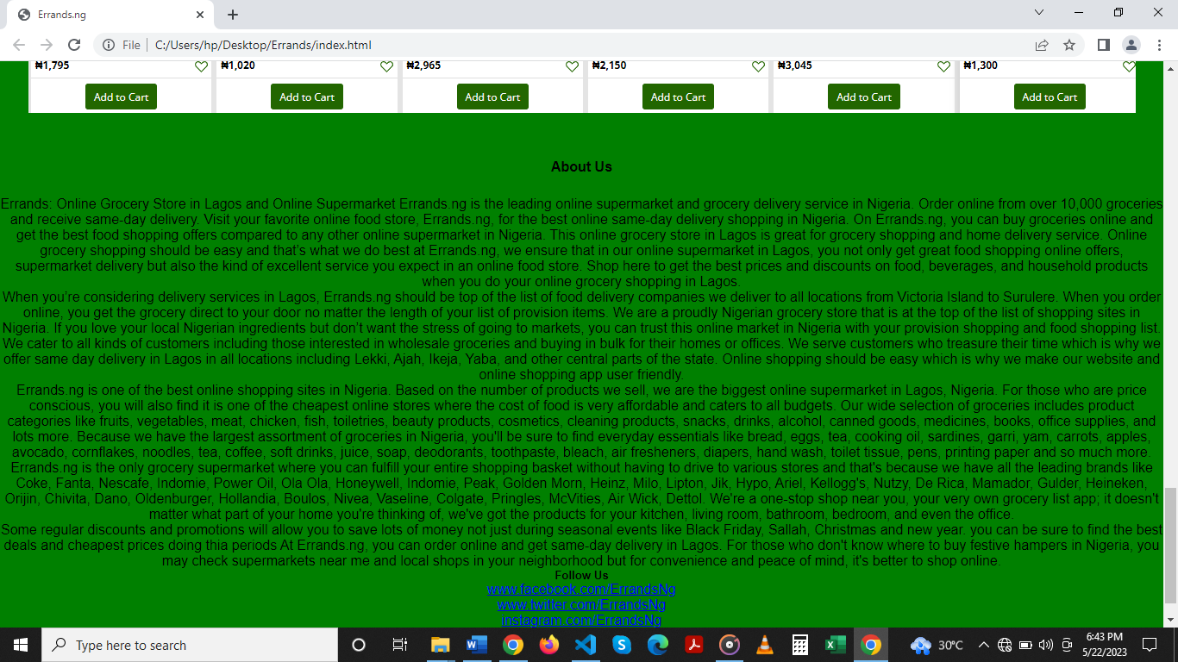

Figure 2 to 5

FEASIBILITY STUDY

* Economic Feasibility

This is a very important aspects to be considered while developing a project. Since no special hardware is required the direct or indirect cost required for the development and the deployment of the project is reduced. As our project consists of a webpage and a mobile application, hence the cost will be for a developer who creates the mobile application/website. we have projected that the benefits the creator is going to receive from the planned system will surely dazed the initial prices and the later on organizational cost for system.

* Technical Feasibility

The project is quite feasible technically as it can be implemented using the support and features provided by the programming languages and handy software tools which are easily available to user. Also with the technical support of the books available, internet resources and internal staff the technical obstacles that are expected/unexpected could be resolved without much delay. Also, there is no special hardware involved in the system. Thus, the overall project is technically feasible having checked if the whole thing was possible using the different types of frontend and backend podiums.

* Market Feasibility

The global online grocery market is growing as disposable income rises. People nowadays want products that meet their comfort levels. People are more likely to spend money on services they can easily obtain and are more willing to save time by shopping online. Online grocery shopping has become an easy and convenient option for many people. Their willingness to pay for these goods is also higher than usual. online grocery market has grown rapidly due to the rapid growth of middle-class populations and advances in internet infrastructure. As a result of being relieved from physically going to stores, people are willing to dispose of their income a little bit more when ordering products online from the comfort of their homes.

* Operational Feasibility

As our project consist of a webpage and a mobile application having a very Simple Graphical User Interface. So to use it a person need not to be a highly technical person, even a common person can use it very easily. The person using our website or application does not need to know any kind of programming languages and also does not need to have technical knowledge. People belonging to any age group can use our website and application without any issues. Overall, our project is very much operationally feasible.

CONCLUSIONS

Our project is to develop an Online Grocery Store, which will provide good quality grocery products at the doorstep to the customers. Major targets of our project are inhabitant of Lagos state, Nigeria.

The major features of our project are:

1. Good quality product

2. Local vendor support

3. Swift delivery within 1 day

REFERENCE

Abusham, E. A., & Al. Zaabi, A. M. (2021). Smartphone application for Self - Management Diabetes: A review. Applied Computing Journal, 1(Issue 1), 25-37. https://doi.org/10.52098/acj.202116

Ashiyanbi J (2005). Review of the Lagos State Regional Master Plan (1980-2000). Lagos State Ministry of Physical Planning. Alausa, Ikeja.

Al-Hatmi, M. O., & Yousif, J. H. (2017). A review of Image Enhancement Systems and a case study of Salt &pepper noise removing. International Journal of Computation and Applied Sciences (IJOCAAS).

Ayo, C., Ekong, O., Fatudimu, I. and Adebiyi, A. (2007) M-Commerce Implementation in Nigeria: Trends and Issues. Journal of Internet Banking and Commerce, 12, 1-15.

Doherty, N. and Ellis-Chadwick, F. (2010) Internet Retailing: The Past, the Present and the Future. International Journal of Retail and Distribution Management, 38, 943-965. https://doi.org/10.1108/09590551011086000

Doole, I. and Lowe, R. (2004) International Marketing Strategy: Analysis, Development and Implementation. 4th Edition, Cengage Learning, Boston

Groceries". Cambridge Dictionary <https://dictionary.cambridge.org/us/dictionary/english/groceries>

Hagel, J. (1999) Net Gain: Expanding Markets through Virtual Communities. Journal of Interactive Marketing, 13, 55-65. <https://doi.org/10.1002/(SICI)1520> 6653(199924) 13:1<55::AID-DIR5>3.0.CO;2-C

Hardy J, Diana M, Scallerthwaite D (1996). Environmental Problems in Third World Cities. Earthscan. London

LAGOS STATE GOVERNMENT Agricultural Sector Deal Book 2018 <https://lagossdgandinvestment.com/Agriculture-Deal-Book-Optimized.pdf>

National population commission: 2006 national population census https://nationalpopulation.gov.ng

Pender, J. Rural population growth, agricultural change and natural resource management in developing countries: The case of fast-growing metropolitan area (Concepcion, Chile). Biol. Conserv. 1999, 127, 272–281.

This day newspaper thur 18th may 2023 <https://www.thisdaylive.com/index.php/2022/09/16/56-of-nigerias-agricultural-land-not-in-use-says-minister/>

Types of feasibility,<https://www.simplilearn.com/feasibility-study-article#:~:text=The> 5 types of feasibility.

Vaz, E.; De Noronha, T.; Nijkamp, P. Exploratory landscape metrics for agricultural sustainability. Agroecol. Sustain. Food Syst. 2014, 38, 92–108.

Vellido, A., Lisboa, P.J.G. and Meehan, K. (2000) Quantitative Characterization and Prediction of Online Purchasing Behavior: A Latent Variable Approach. International Journal of Electronic Commerce, 4, 83-104. <https://doi.org/10.1080/10864415.2000.11518380>

Wong, C.H., Lee, H.S., Lim, Y.H., Chua, B.H., Chai, B.H. and Tan, G.W.H. (2012), Predicting the consumers’ intention to adopt mobile shopping: an emerging market perspective., International Journal of Network and Mobile Technologies, Vol. 3 No. 4, pp. 24-39

Xie, Kang (2004). A Strategic Analysis of Online Grocery and Its Future Outlook. Massachusetts Institute of Technology, Engineering Systems Division.

Yang,K.and Kim,H.-Y.(2012). Mobile shopping motivation: an application of multiple discriminant analysis, International Journal of Retail & Distribution Management, Vol. 40 No. 10, pp. 778-789 " (2nd ed.). 1989.